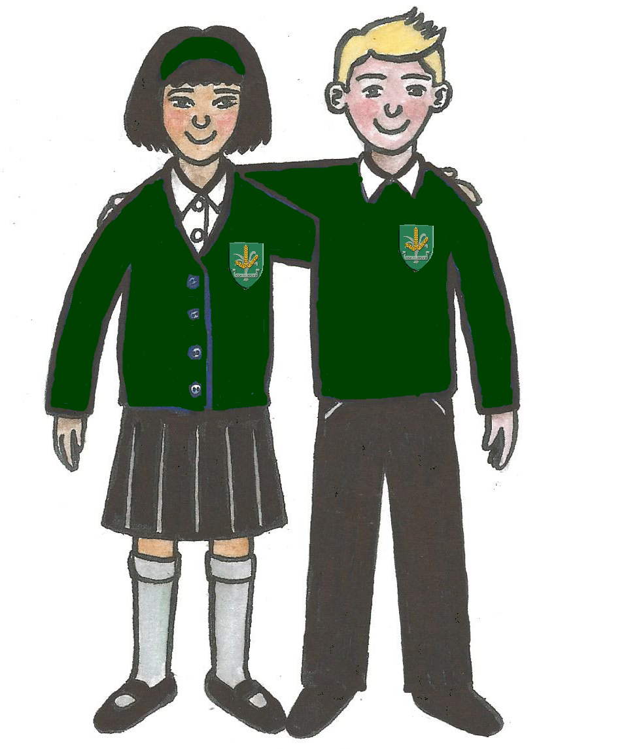
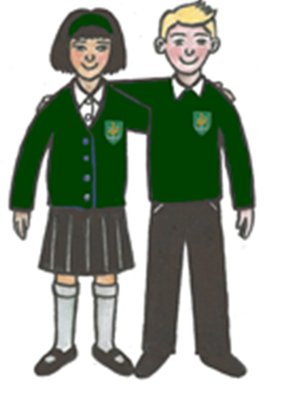
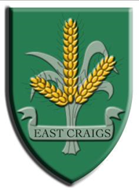
What will I be learning in P6B
Term 4 2018/19
2018-19
Discrete Subjects
Literacy
Talking and listening skills (sharing information and experiences), reading (Active Literacy and skimming and scanning techniques) and writing (conveying information). During Term 4 in grammar we will focus on nouns and proper nouns. Weekly spelling activities will help us consolidate spelling patterns and rules.
Maths and Numeracy
We will be focussing on time, in particular the duration of time and using timetables and calendars. In measure we will be looking at area, perimeter and volume. We will be using our estimation skills within measure, to make accurate predictions throughout. We will also be revisiting sequencing and pattern in numbers.
Science
With our science specialist, Ms Clouston, pupils were be learning about forces.
PE
We will be taught by our PE Specialist and will develop our skills in athletics, track and field and outdoor games. This will be in preparation for our sports day and enhancing our leadership skills.
Modern Foreign Languages
We will continue to enhance our knowledge of French through familiar words and phrases in increasingly full sentences. In German we will be learning the months of the year and vocabulary associated with sports and games.

Ethos and Wider Life of the School:
We are learning to be responsible citizens and developing our awareness of the world through:
Resilience/Growth Mindset
To understand that my feelings and reactions can change depending upon what is happening within and around me. This helps me to understand my own behaviour and the way others behave.
To understand that friendship, caring, sharing, fairness, equality and love are important in building positive relationships. As I develop and value relationships, I care and show respect for myself and others. To make full use of and value the opportunities I am given to improve and manage my learning and, in turn, I can help to encourage learning and confidence in others.
Houses
Each pupil will be earning credits toward their Bronze, Silver or Gold House point card and take part in Sports Day as an active member of one of the three houses: Maybury, Barnton and Almond.
Buddies
With our Nursery buddies we will be continuing to build positive relationships through a variety of curricular activities.
JASS
Pupils will complete their bronze award for JASS by taking part in “Orienteering”. This session the tasks will be largely completed in school .

Interdisciplinary Learning:
The Victorians
Through our Victorian topic we will be learning about people and society in the past and comparing this to the modern day. We will be looking at the lives of children in the workhouse and school life in comparison with our lives today.

Keeping Myself Safe
Throughout Keeping Myself Safe we will be considering different scenarios in a variety of settings, (which present a danger or concern to our emotional and/or physical safety) and identifying through discussion appropriate responses and personal safety strategies to deal with these situations appropriately.

Happy, Healthy and Fantastically Fit
During our health week focus, the pupils will be taking part in a number of different physical activities. We will also be examining ways to look after our mental and emotional health and how we can implement this into our daily lives.

Transition
Towards the end of the term we will be looking at strategies to support ourselves and our peers during challenging times in relation to change. We will look at practical ways of getting support both physically and emotionally.

Planned Opportunities for Wider Achievement:
We are learning to celebrate our achievements through:
JASS
Bikeability- as part of our “Get Active, Stay Active” award, our pupils will be completing level 1 or level 2 of their bikeability award.
Orienteering- supported by the Edinburgh Orienteering Society we will be completely a 5 week course in orienteering as part of our “Adventure” award in JASS.
Team EC Award
Celebrating personal achievement through nomination for the weekly Team EC Award and receiving whole school recognition.

.

Successful Learner
Effective Contributor
Confident Individual
Responsible Citizen

